Quadratic Equation Worksheet
Complete the following worksheet using Geogebra
Draw the following equations and use the graphs to find the roots
(i) y = 2x² + 11x – 13 (ii) y = x² – 4x – 5 (iii) y = 3x² + 8x – 13

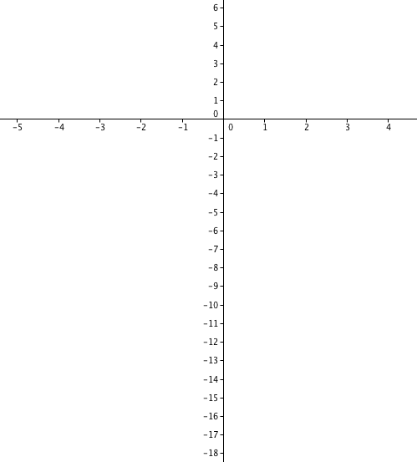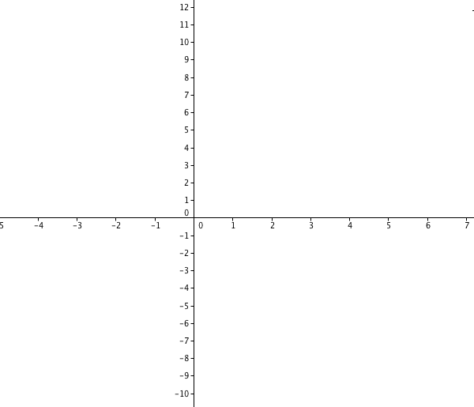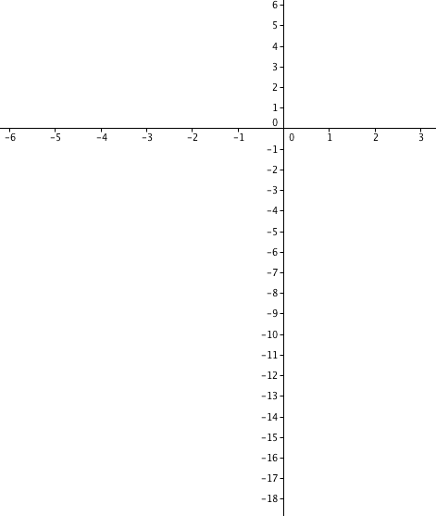
Roots: ______ ________ Roots: ______ ________ Roots: ______ ________

Investigation
Every quadratic has the general formula y = ax² +bx + c
(i) Investigate what happens if:
“a” is increased “b” is increased “c” is increased
_______________________________ ___________________________________ _____________________________________
_______________________________ ___________________________________ _____________________________________
_______________________________ ___________________________________ _____________________________________
_______________________________ ___________________________________ _____________________________________
_______________________________ ___________________________________ _____________________________________
_______________________________ ___________________________________ _____________________________________
_______________________________ ___________________________________ _____________________________________

(ii) Investigate what happens if
a = 0 b = 0 c = 0
_______________________________ ___________________________________ _____________________________________
_______________________________ ___________________________________ _____________________________________
_______________________________ ___________________________________ _____________________________________
_______________________________ ___________________________________ _____________________________________
_______________________________ ___________________________________ _____________________________________
_______________________________ ___________________________________ _____________________________________
_______________________________ ___________________________________ _____________________________________

Investigate what happens if:
a < 0 b < 0 c < 0
_______________________________ ___________________________________ _____________________________________
_______________________________ ___________________________________ _____________________________________
_______________________________ ___________________________________ _____________________________________
_______________________________ ___________________________________ _____________________________________
_______________________________ ___________________________________ _____________________________________
_______________________________ ___________________________________ _____________________________________
_______________________________ ___________________________________ _____________________________________

Any other observations?
______________________________________________________________________________________________________________________
______________________________________________________________________________________________________________________
______________________________________________________________________________________________________________________
____________________________________________________________________________________________________________________

